**ECS PIPELINE Using Terraform**

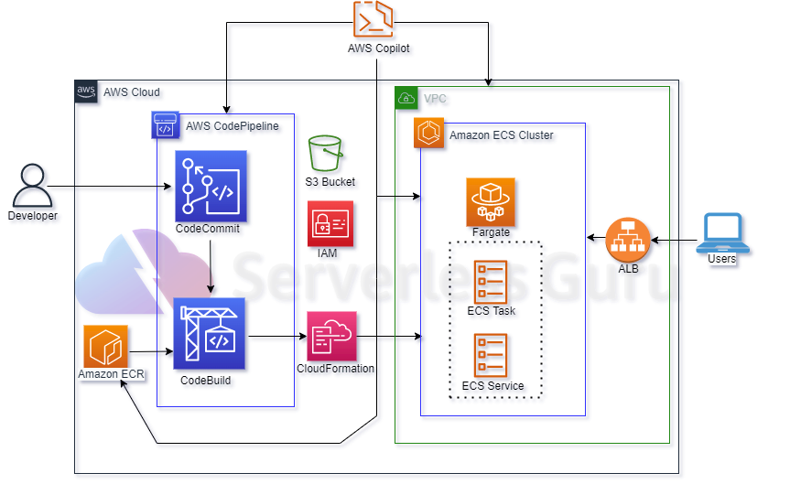

**Using Terraform**

Using terraform we have to create an infra that have ECS CI/CD pipeline in to and source will be AWS Codecommite. Service that we will be creating using Terraform.

* **VPC** that have public **subnets** attached with internet gateway.
* **ECS cluster on fargate** on which we will be deploying our application.
* **ECS task and services** that are required to run a container on ECS cluster.
* **Loadbalancer** to access deployed containers on ECS Cluster.
* **ECR repo** that will store our docker images that we will be deploying on ECS Cluster.
* **Codebuild** that will push our updated docker image on ECR repo.
* **CodeCommit** repo to store our application with buildspec.yml file.
* **S3** to store artifact made by CodeBuild.
* **Codepipeline** have source as **CodeCommit** and build with **CodeBuild** and deploy on **ECS Cluster.**
* **Policy’s and role’s** as per these services required.